**Test DNS setup**

IP address of ns.attacker32.com  
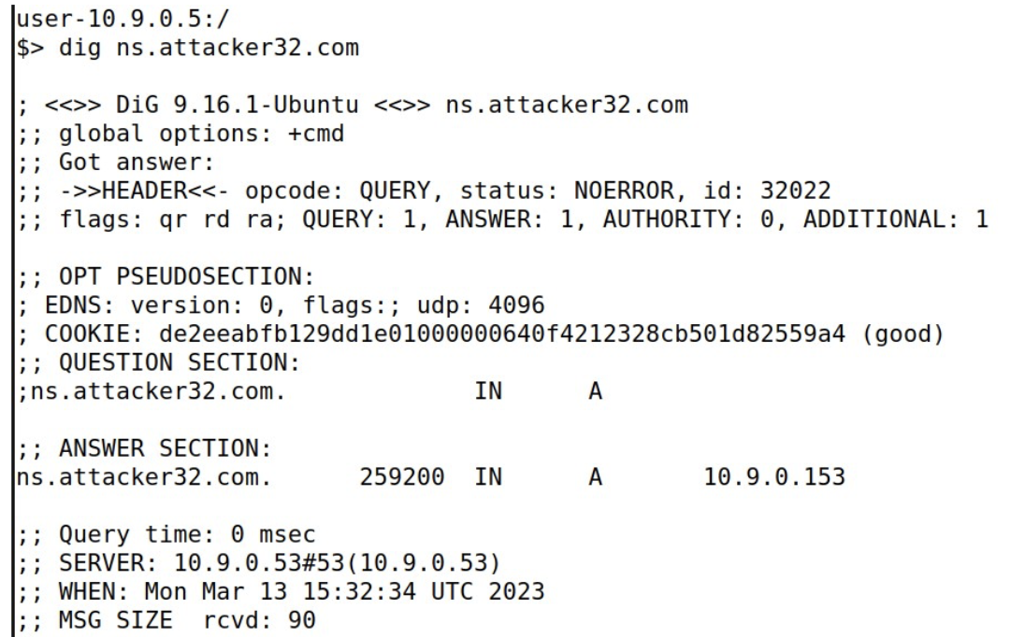

IP address of www.example.com

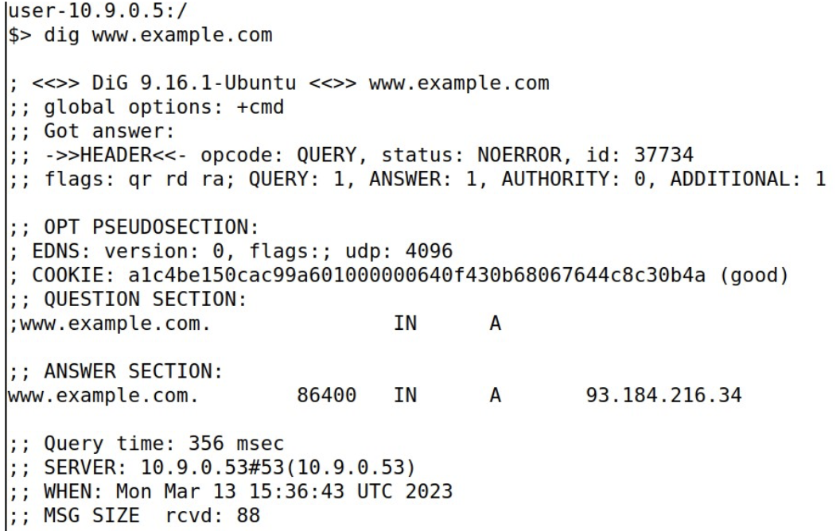

Fake IP address of www.example.com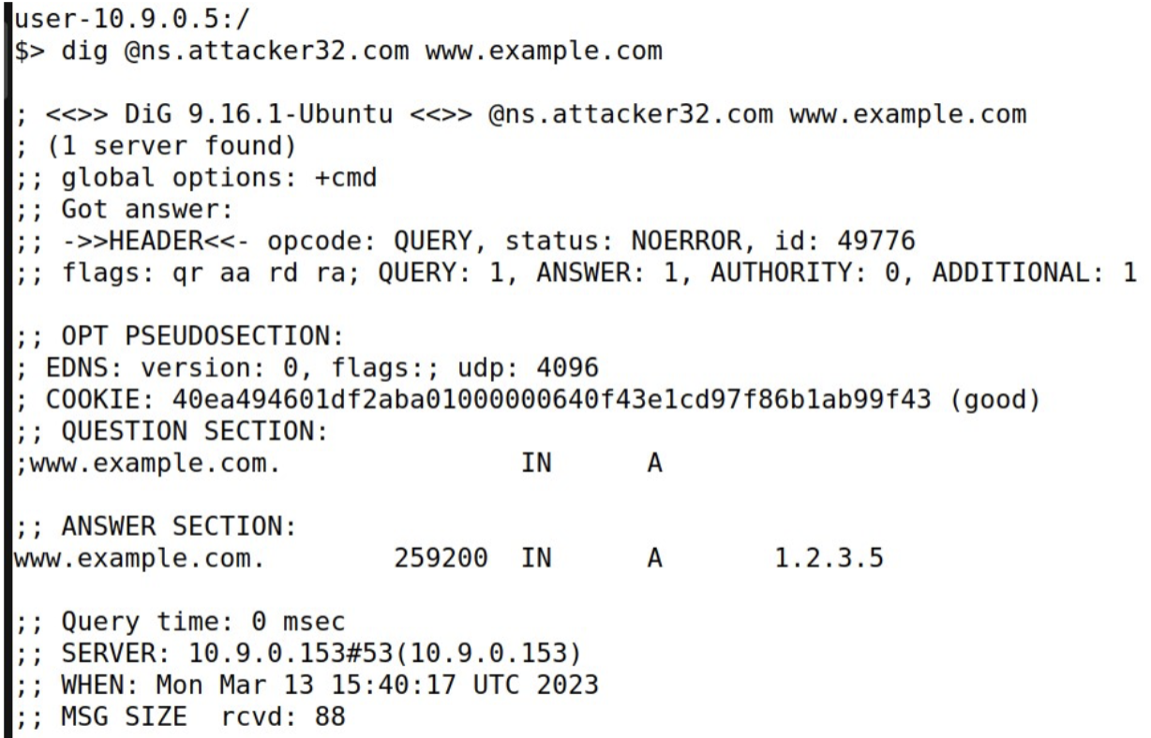

**Task 1**

**Code**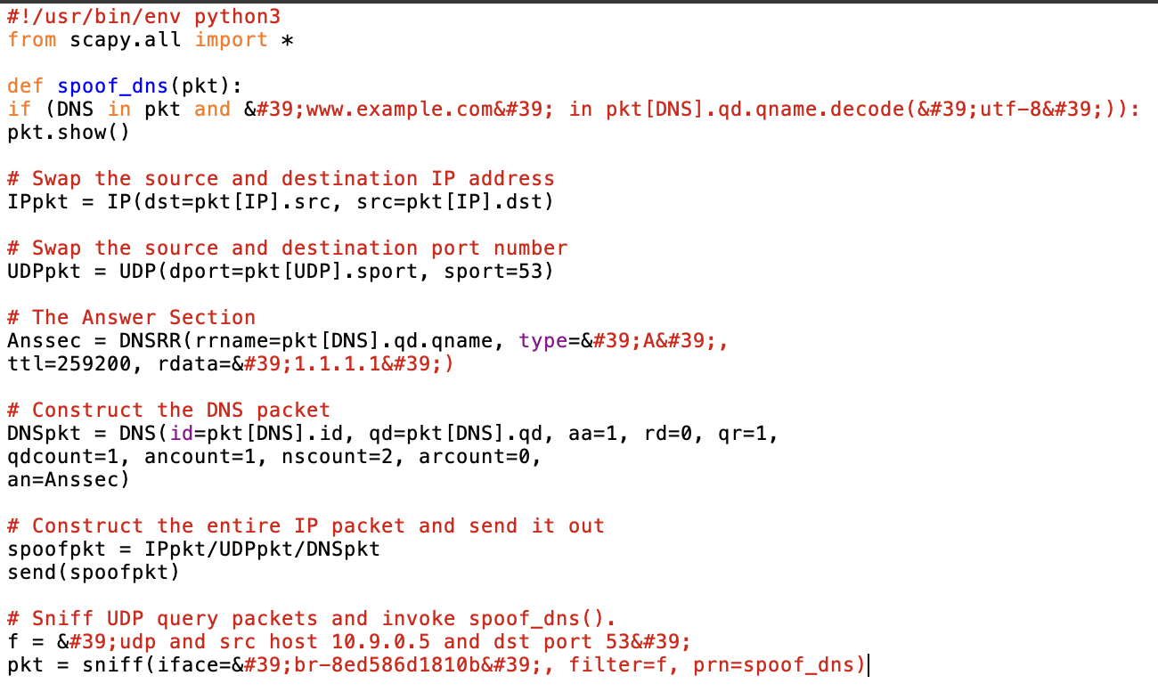

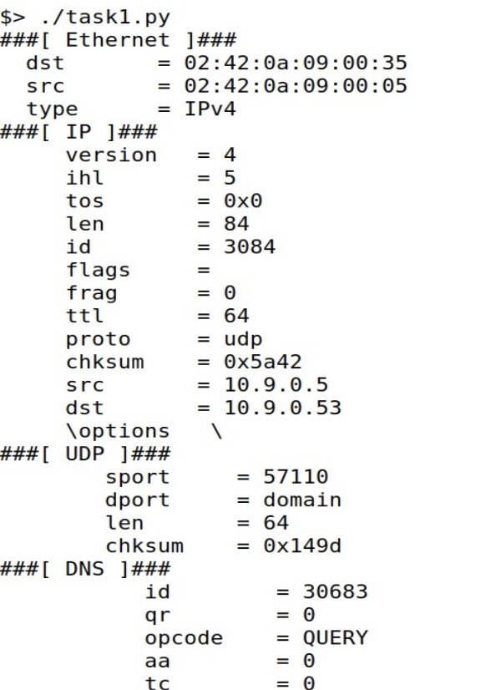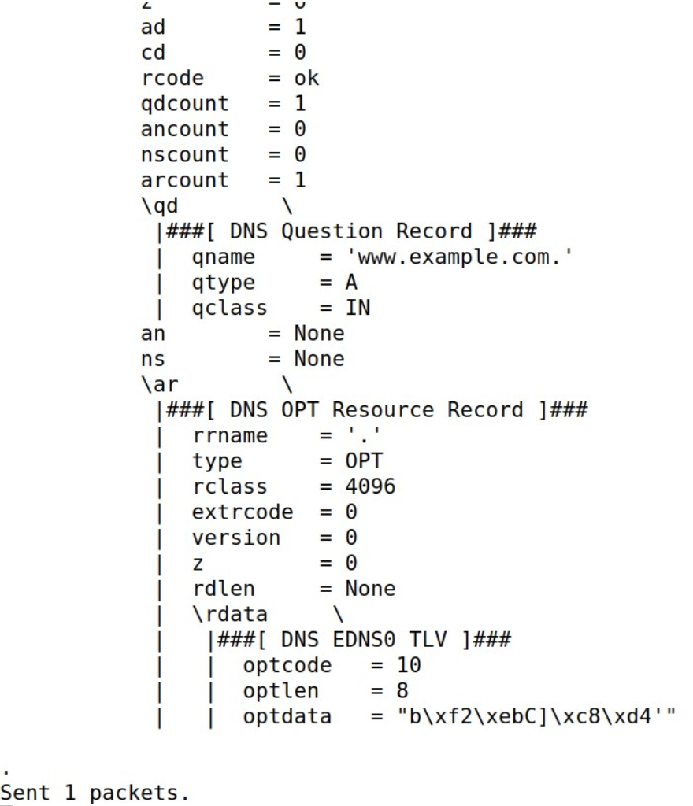

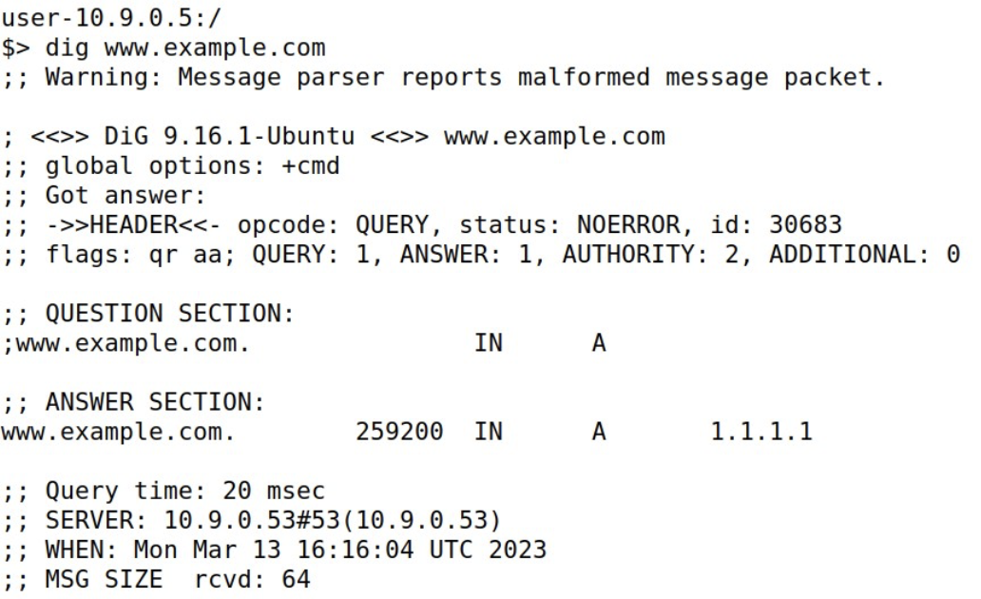

**Description**

We run the code and check use **dig** to get fake ip address. If we dont get it we have to delete the ip address using **rndc flush** command.

**Task 2**

**Code**

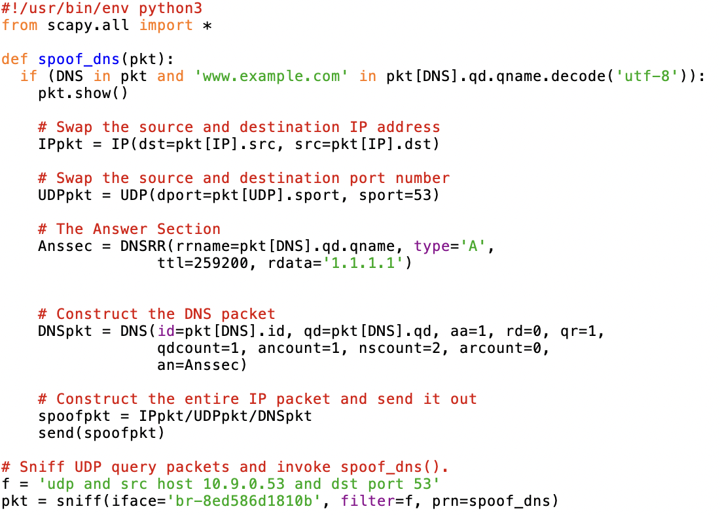

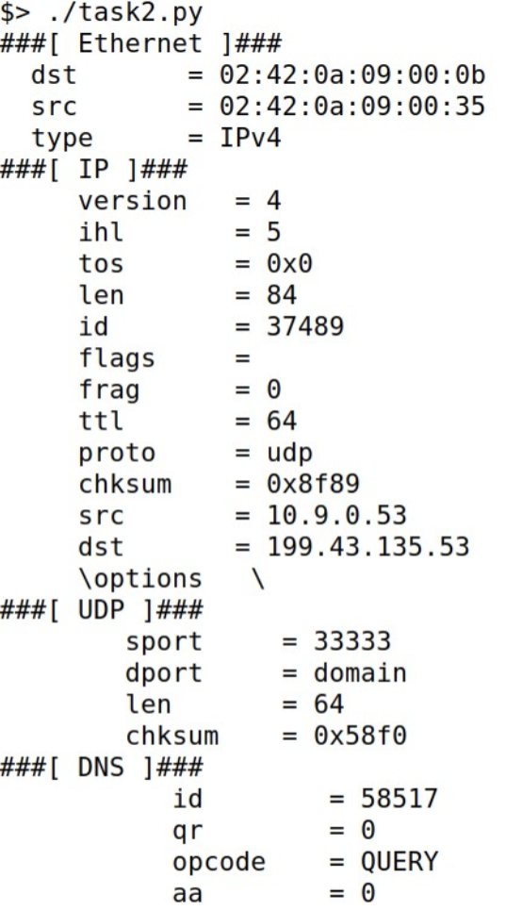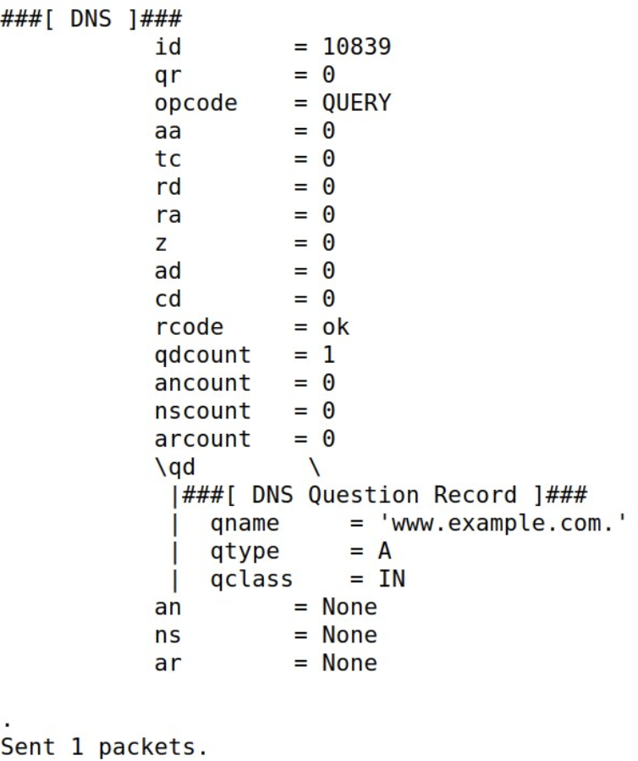

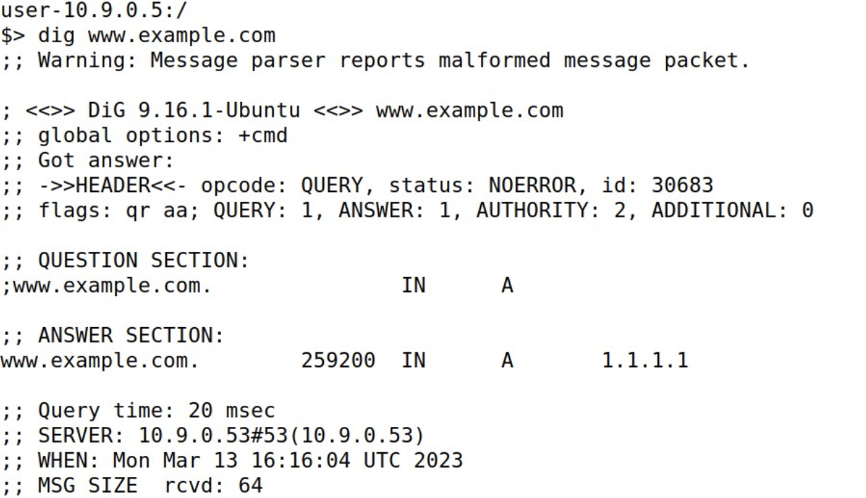

**Description**

We use **rndc flush** to clean cash the run the code and check the cache using **dig** command.

**Task 3**

**Code**

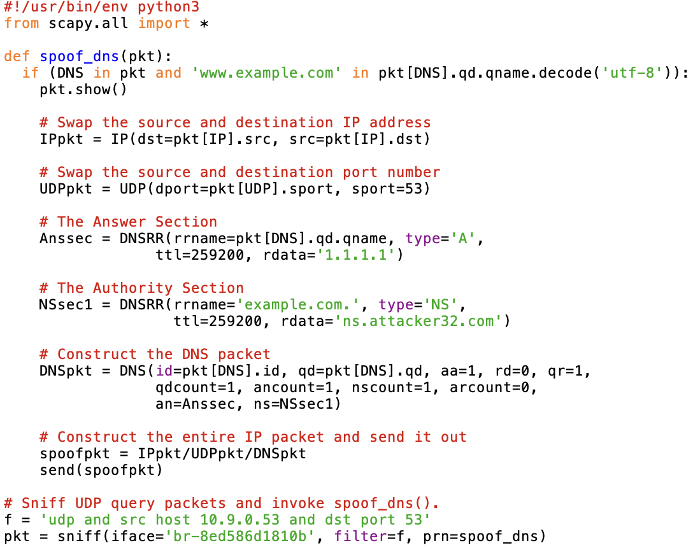

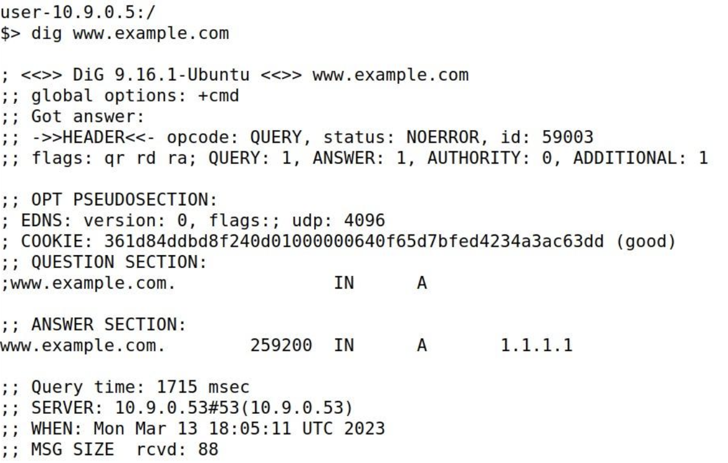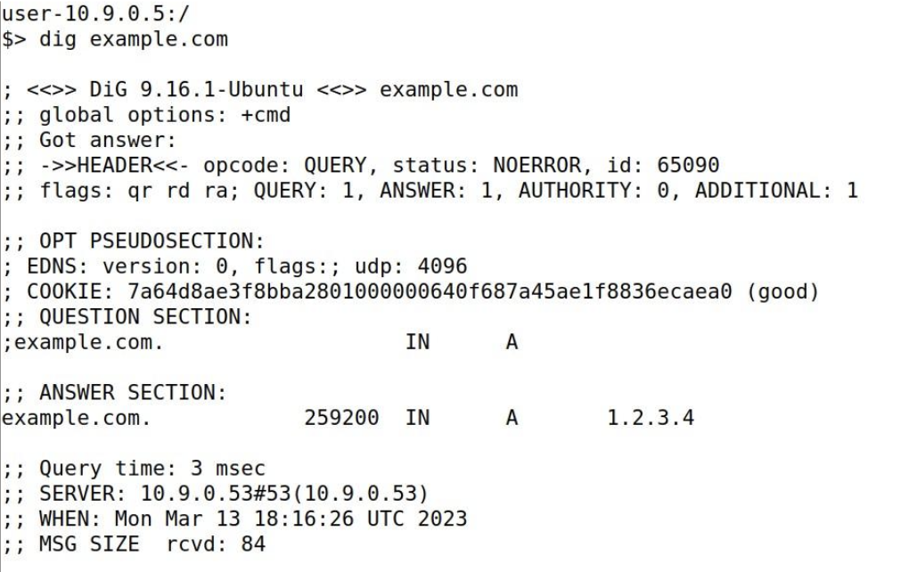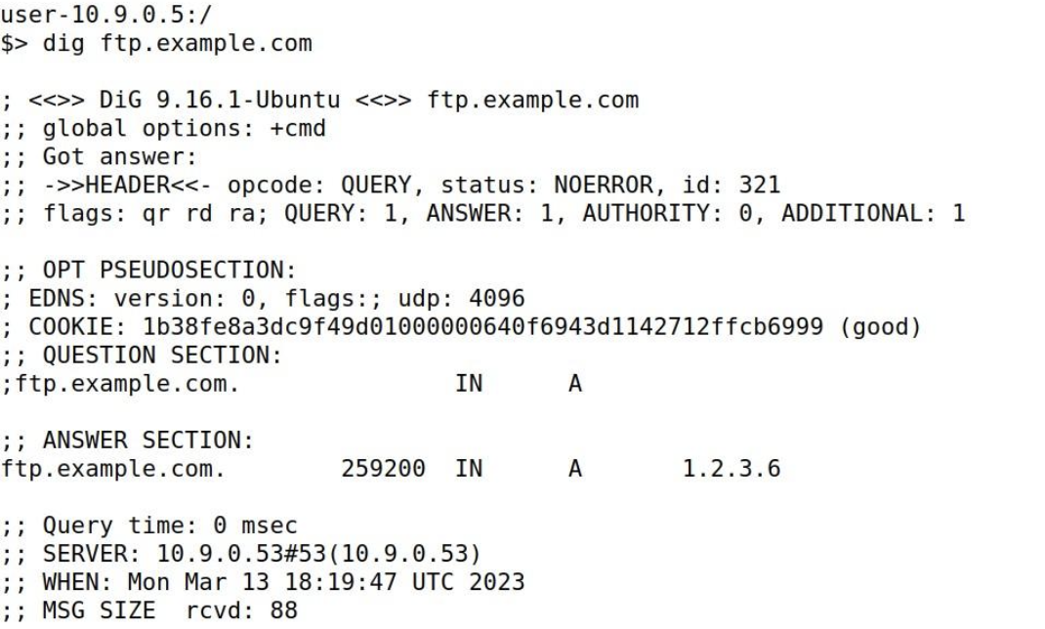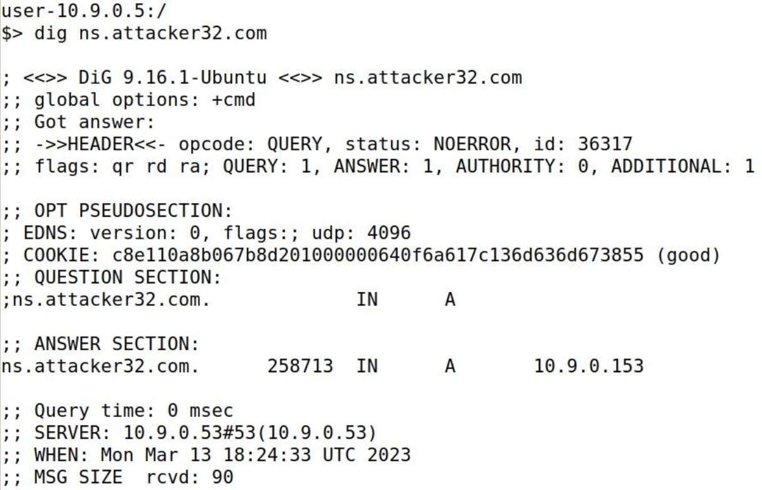

**Description**

We ran the code after using **rndc flush** to clear the cache then check all the ip addresses using **dig.**

**Task 4**

**Code**

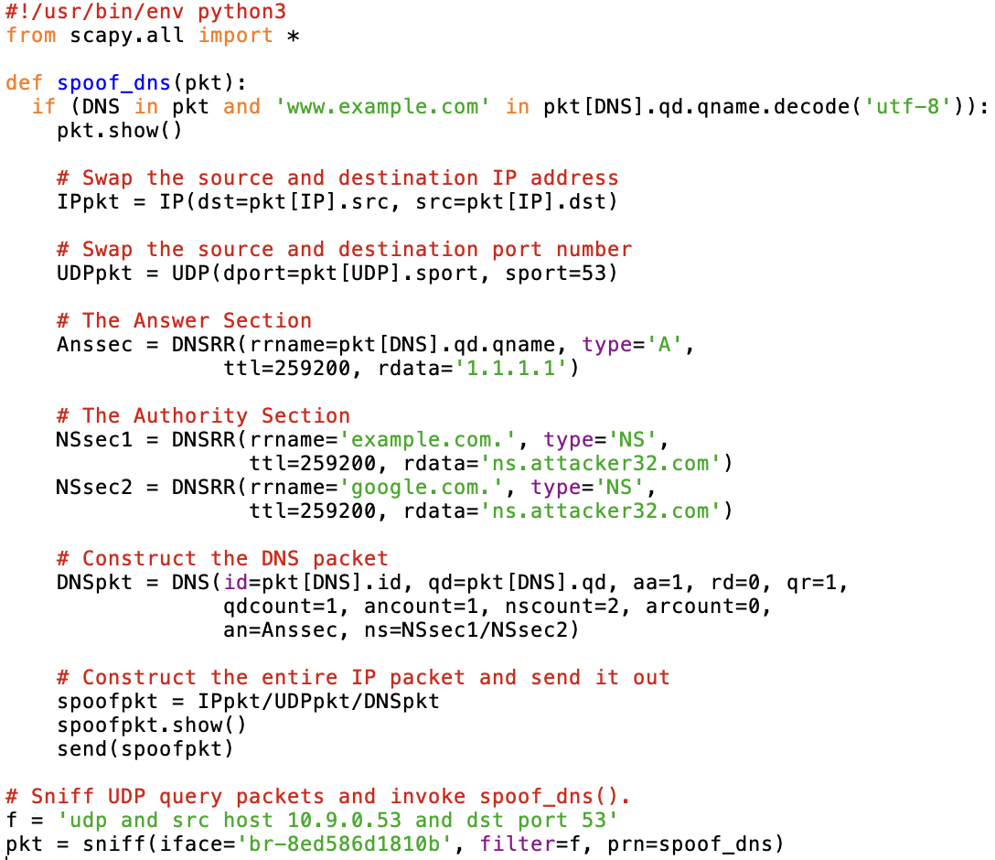

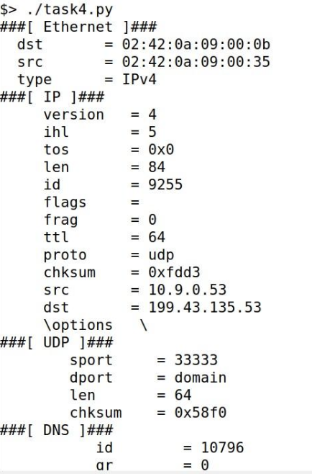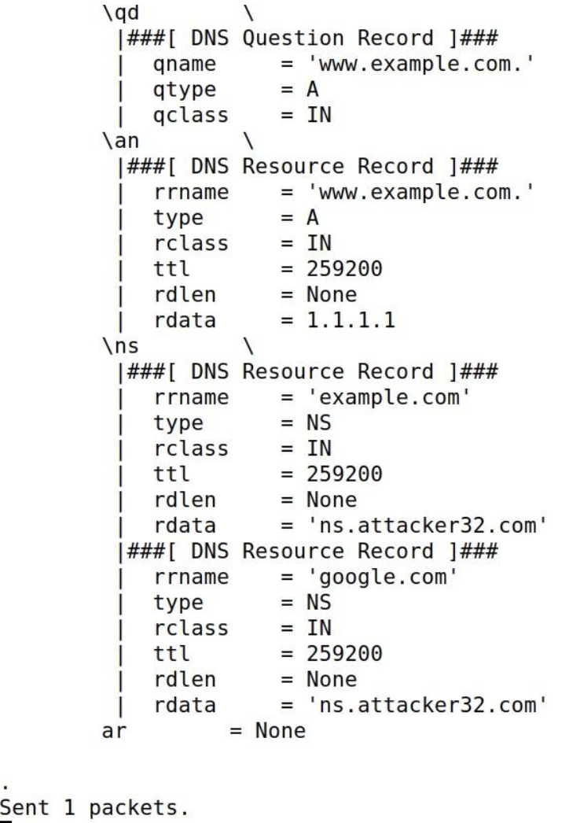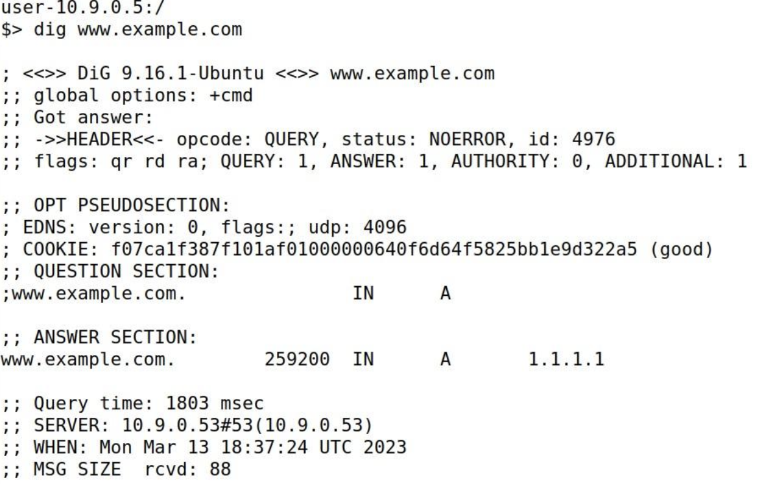

**Description**

We used **rndc flush command** to clear cache as usual. Then, we run the code and check answer using **dig** command.

**Task 5**

**Code**

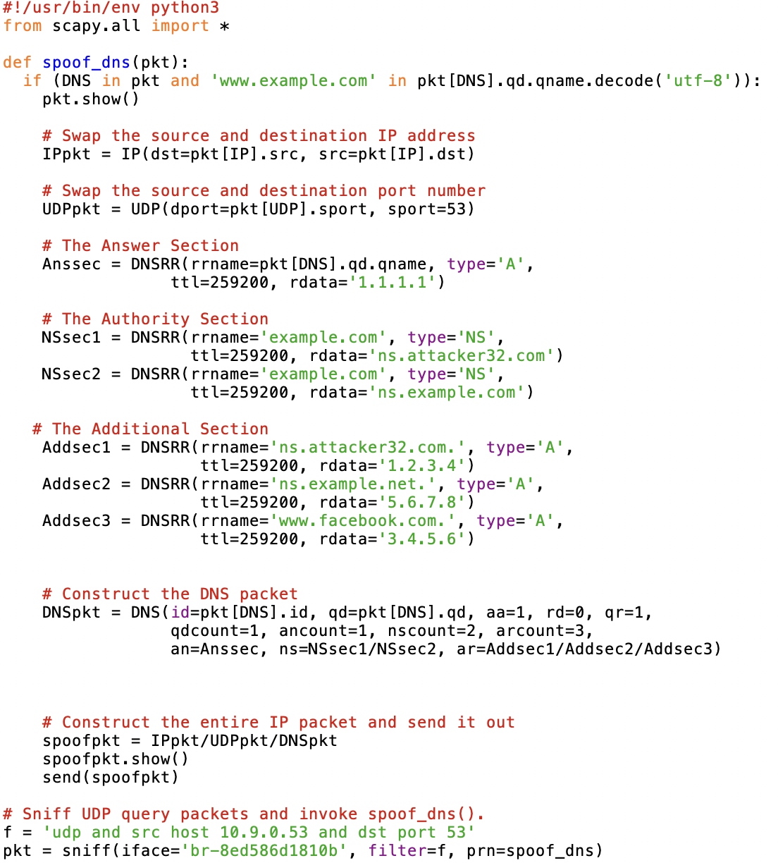

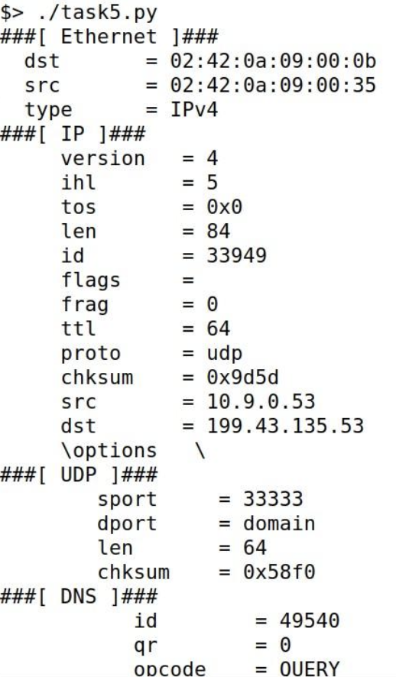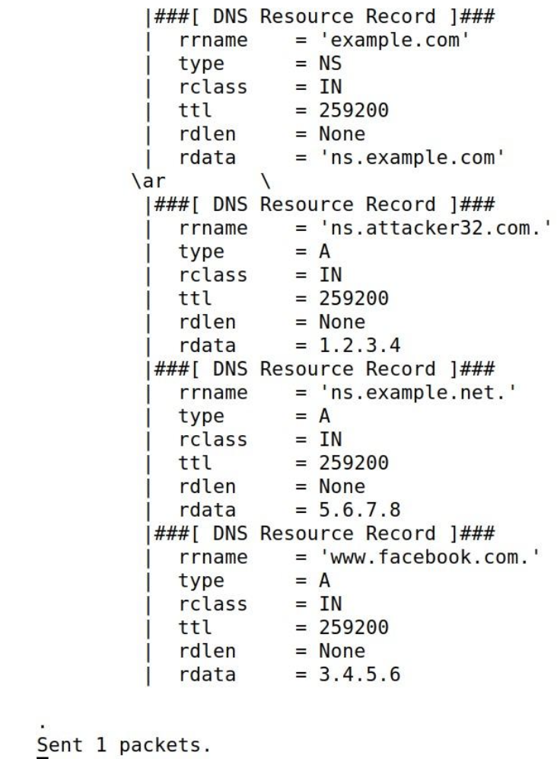

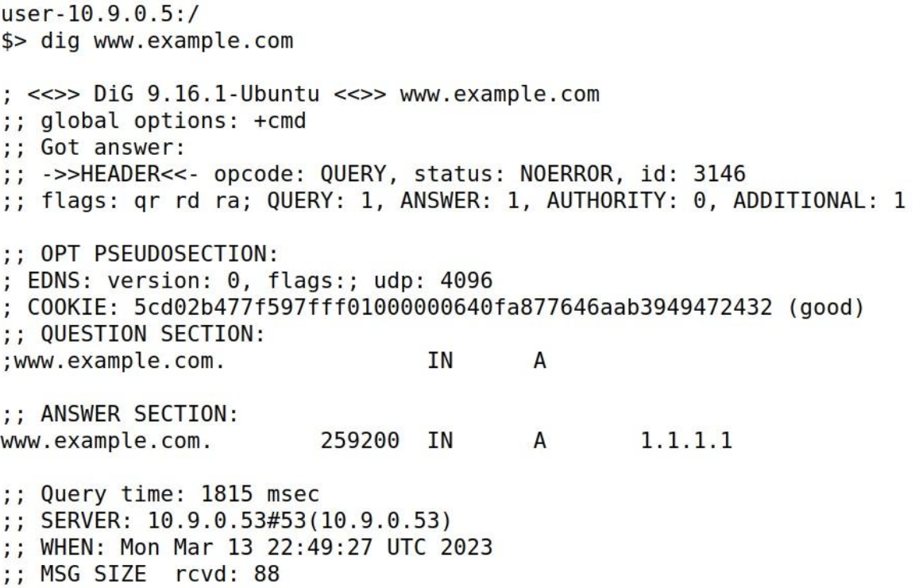

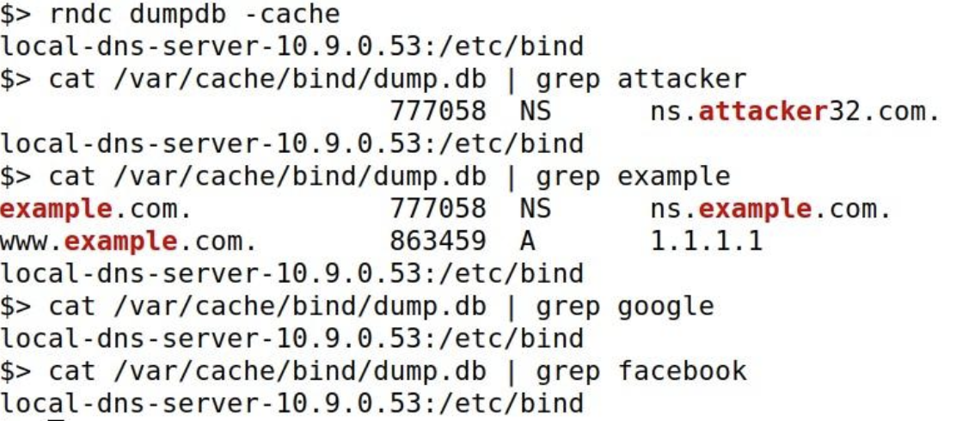

**Description**

So after this testing, I observed that the additional section such as ns.example.net,

facebook.com, google and ns.attacker32.com were not cached while example.com,

www.example.com, ns.example.com were cached because there is no setup or configuration present in our setup.